**Bank Churn Tableau Questions**

**Cleaning the data**

The reason I chose to drop the rows where there were null values in the card category columns and credit limit columns was because there is no one who I could ask that could have a knowledge of this. There was also no correlation between card category/credit limit vs income category/age/education level/attrition flag. You would think that the older, the more education or a higher income would be a direct correlation of a platinum card or a higher credit limit but this was not the case

1. **Display the percentage of the attritted and the existing customers from the data.**

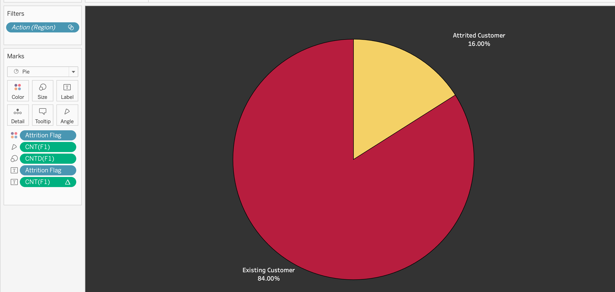

Used a pie chart to show the percentage difference. 86% were existing customers and 16% were attrited customers.

1. **Task 2: Display gender-wise percentage of the attritted and the existing customers.**

I used a stacked bar chart to display this . I categorized it by attritted customers and then divided the bar up by gender. There were 39.5% female existing customers, 44.5% male existing customers, 8.3% female attritted and 7.7% attritted male customers.

1. **Task 3: Display region-wise percentage of the attrited and the existing customers.**

Similarly, I used a stacked bar chart but this time stacked the attritted and existing customers on the bar chart and categorized it by region. England had the most customers and Northern Ireland had the least.

1. **Task 4: Display the percentage of the attrited and the existing customers for each card category.**

Also used a stacked bar chart and there was a noticeable difference between card categories. Almost all the customers were blue card holders and there were very minimal platinum card holders. This was a key observation because it raises questions on why there are so few higher card holders.

1. **Task 5: Display the percentage of the attritted and the existing customers for each income category.**

I used a stacked chart to see the attritted customer count based on income category. After seeing the last chart, it’s to no surprise that the majority of the card holders were those that make below 40k.

1. **Task 6: Display region-wise count of customers. Identify the region that has the maximum number of customers.**

England has the highest count of customers . This could be due to population size.

1. **Task 7: Create an interactive dashboard:**

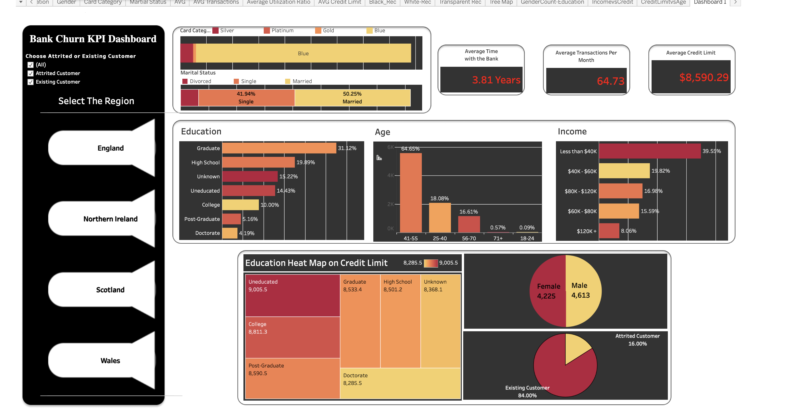

Created a dashboard categorized by region. Added icon that allows for a click effect when clicking on the region and all the charts within the white space filter to that region. Also added another filter on the upper left hand side. You can filter the data between existing and no existing customers.

Questions of my Interest:

1. Count of Education Level (Side chart)

1. Age vs credit limit-

Slight positive correlation for males

Slight negative correlation for females

1. A screenshot of a computer

   Description automatically generated
2. Average Credit Limit
3. Average Utilization Ratio per region
4. Income category
5. Amount spent per region
6. Years of relationship with the bank vs Credit limit offered by the bank on the card- no correlation

